RINGERS QUIZ 2002 – PART DEUX

Part One – The Easy Bit

This is the English literal translation of some corners/sections of the Ring – what is the proper German name of the corner/section?

Swallow’s tail
Flying place
Animal garden
Defence valley
Foxhole
Water mill
Little kettle
Convent valley

…………………………………………………………………………………………..

What is the noise limit, in decibels?

…………………………………………………………………………………………..

What is the minimum speed a vehicle must be capable of to drive the Ring, in km/h?

…………………………………………………………………………………………..

What make and model did Derek Bell do the fifth fastest lap ever in?
Who overtook Derek on that lap?

…………………………………………………………………………………………..

Name the driver of the Ruf Yellowbird in the video “Faszination auf der Nurburgring”?

…………………………………………………………………………………………..

What was the price of a full Jahreskarte in 2002 for car and bike?

…………………………………………………………………………………………..

The Ring has white distance marker signs along the circuit. Name the corner/section at the –

3km sign?
10 km sign?
17 km sign?
20km sign?

…………………………………………………………………………………………..

Where is Sprunghugel?

…………………………………………………………………………………………..

What date was the first foundation stone laid when construction began of the Ring? (1 point for the year; bonus point for the month)

…………………………………………………………………………………………..

What is the name of the section between Hohe Acht and Wipperman?

…………………………………………………………………………………………..

Who did the first ever ‘100 mph’ lap of the Ring? What year?

…………………………………………………………………………………………..

Which vehicle won the 24 hrs race in 2002?

…………………………………………………………………………………………..

What bike did Helmut Dahne set his record lap on? What was the time of that lap?

…………………………………………………………………………………………..

Name six different points where a public road runs underneath the Ring? (point for each)

…………………………………………………………………………………………..

Part Two – The Not So Easy Bit

THE FIENDISHLY DIFFICULT “WHERE IS THIS?” QUIZ

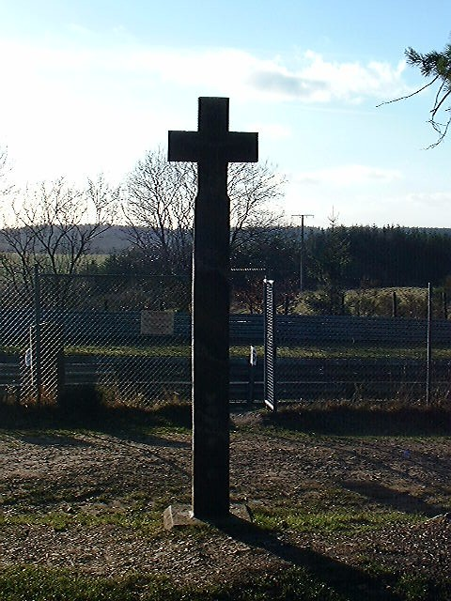

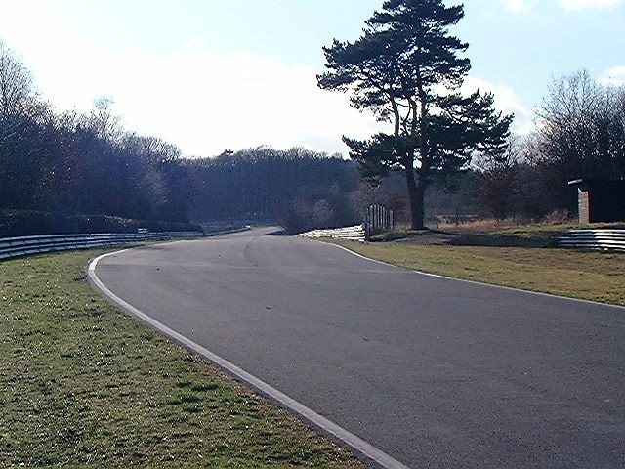

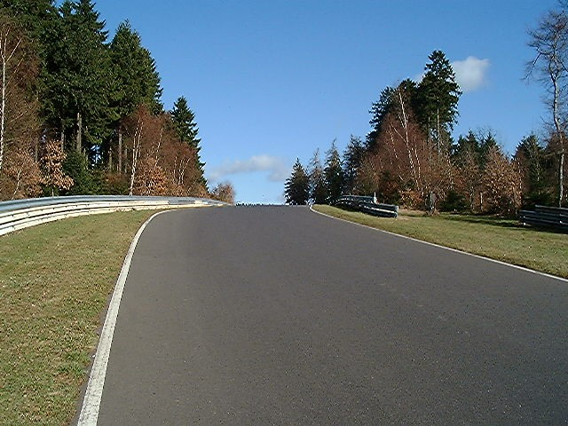

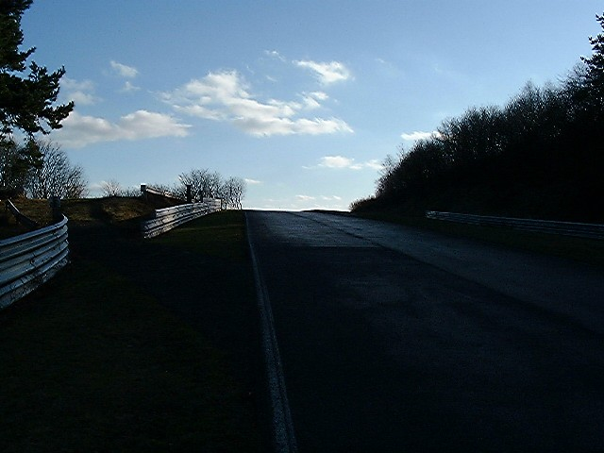

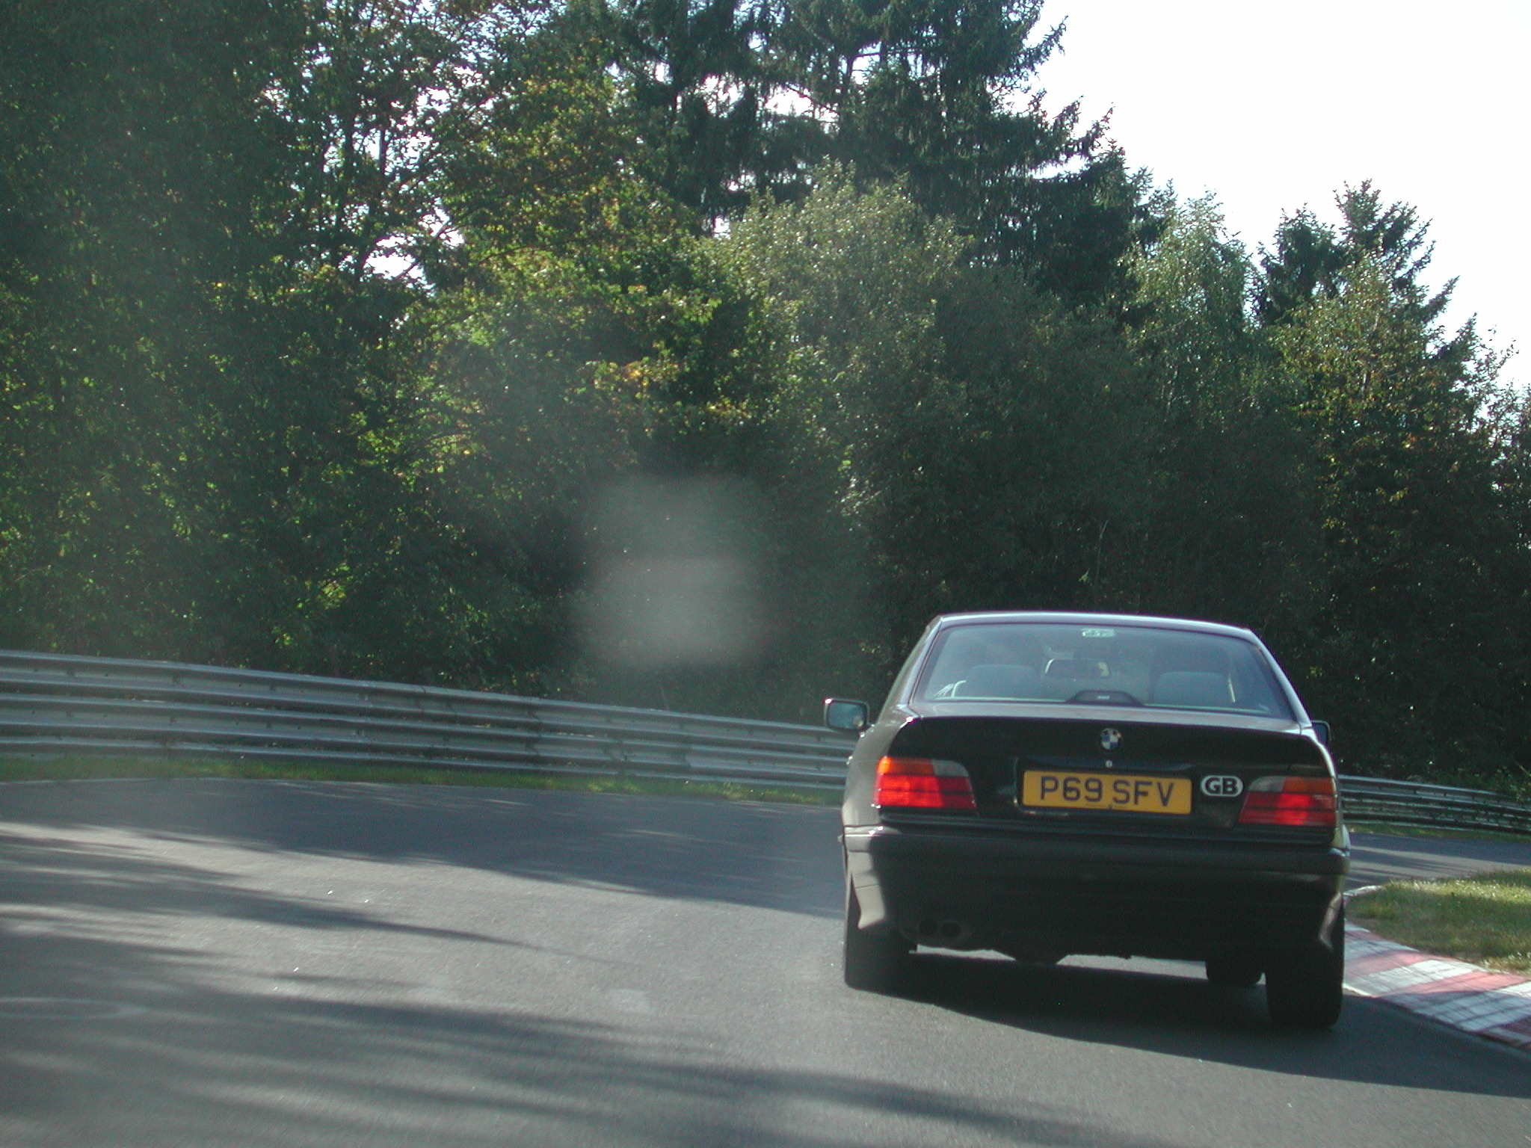

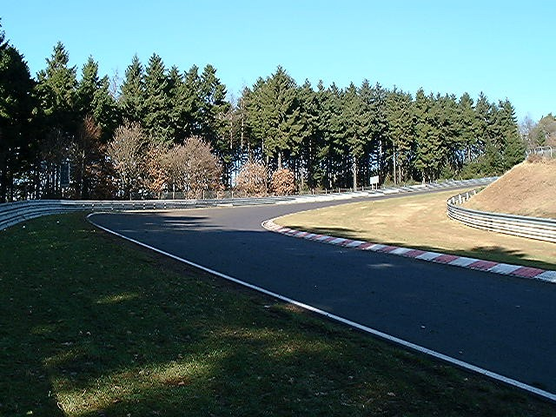

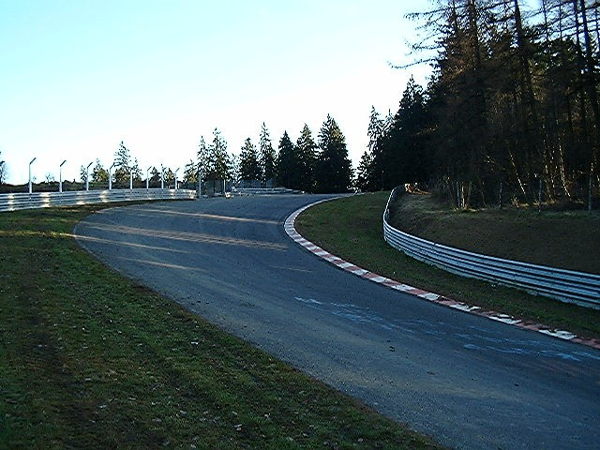

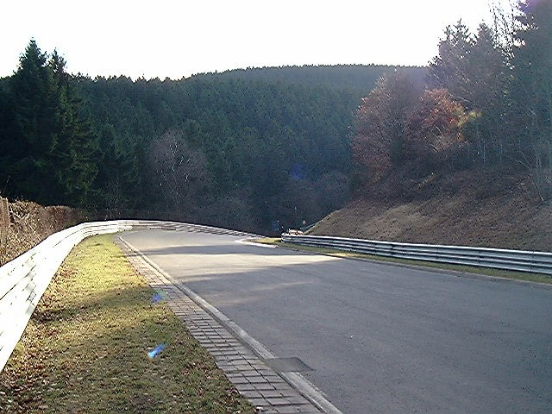

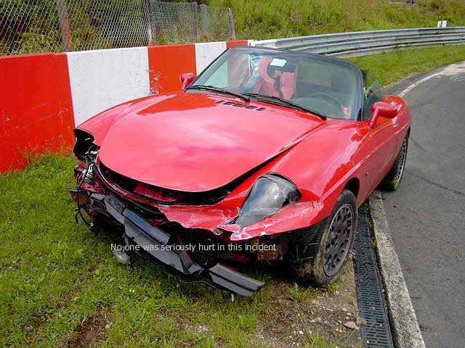

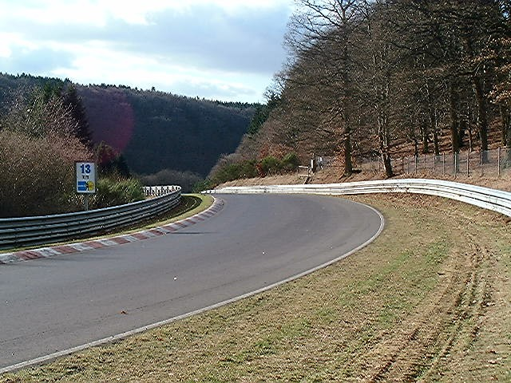

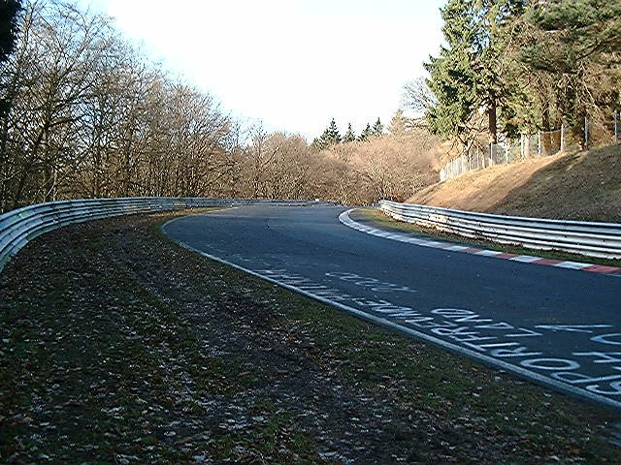

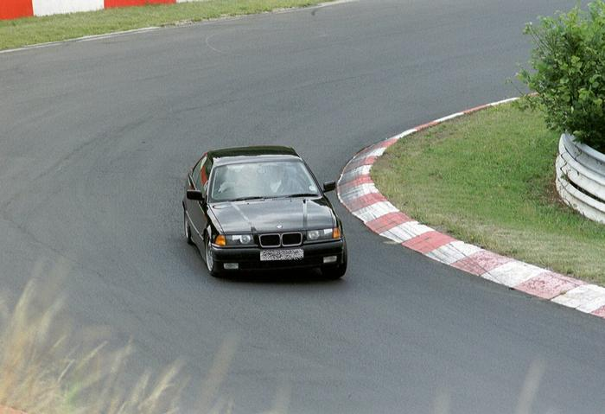

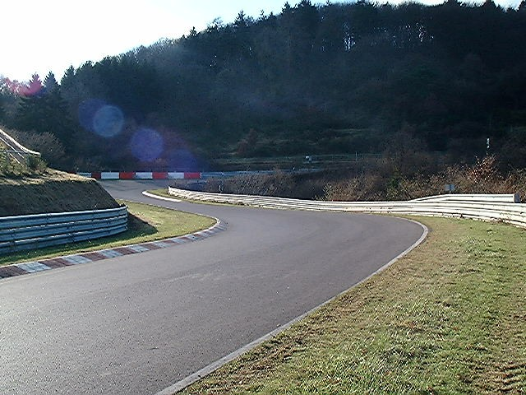

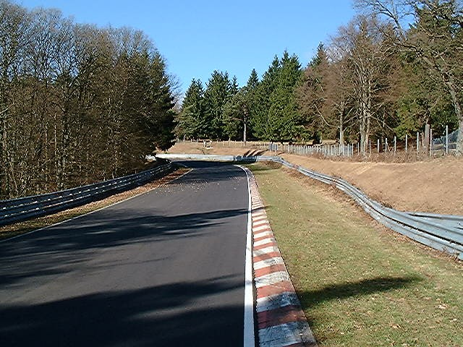

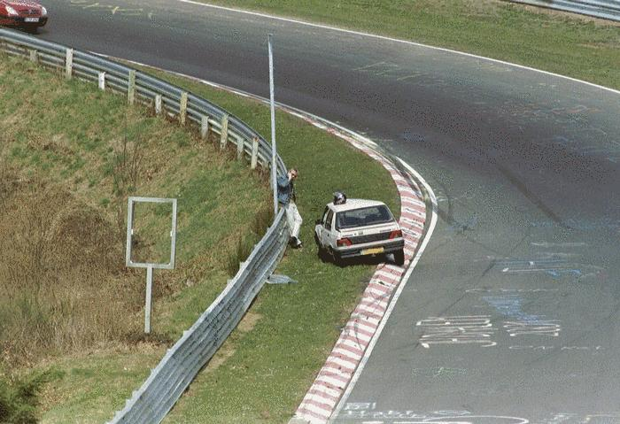

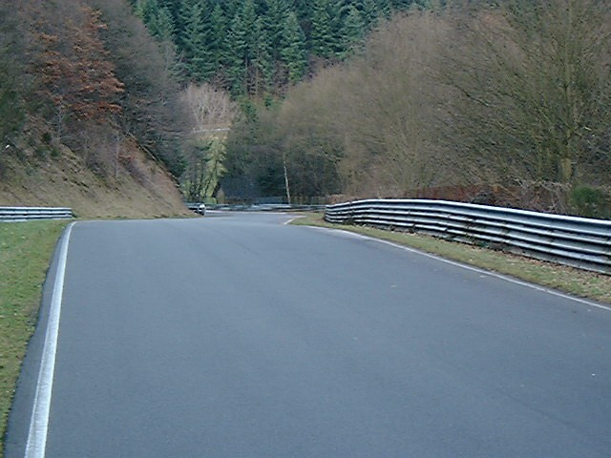

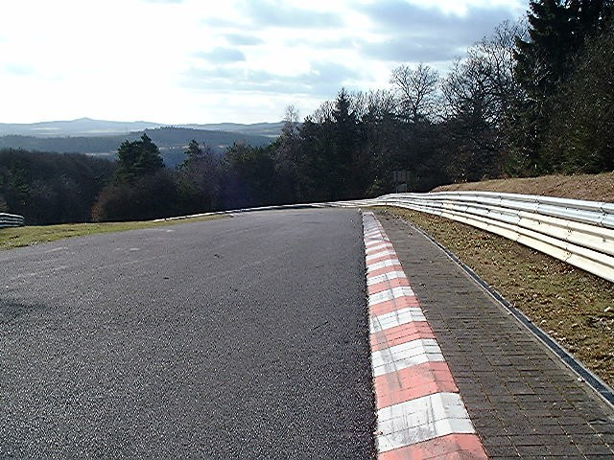

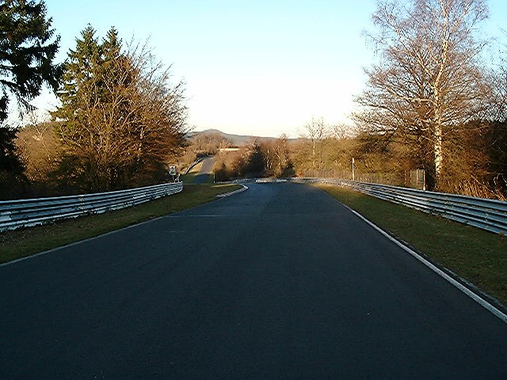

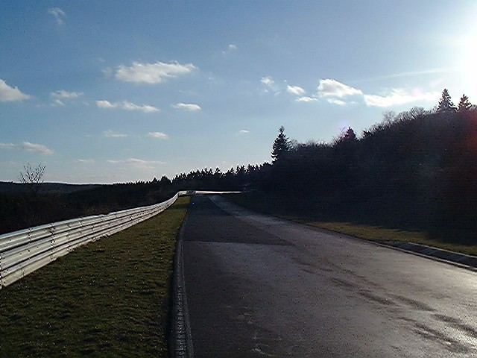

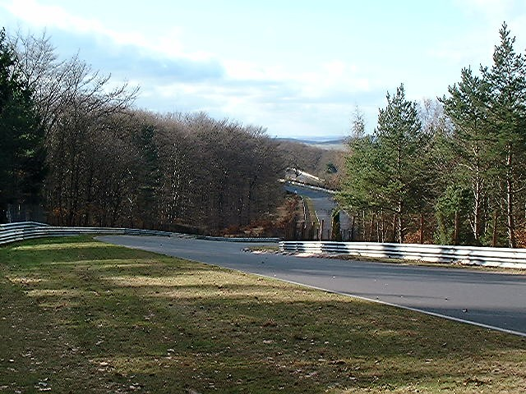

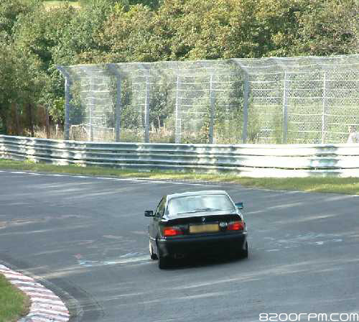

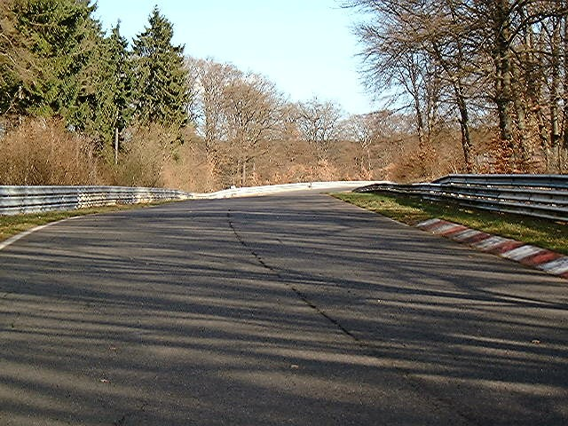

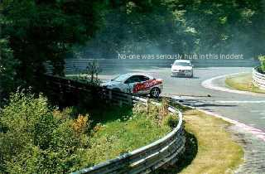

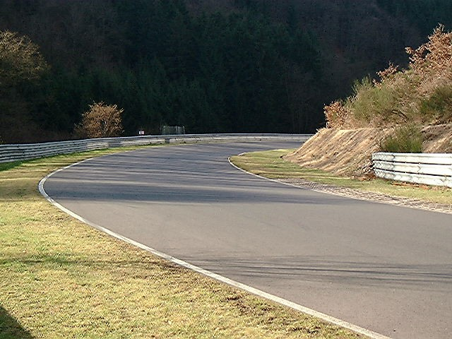

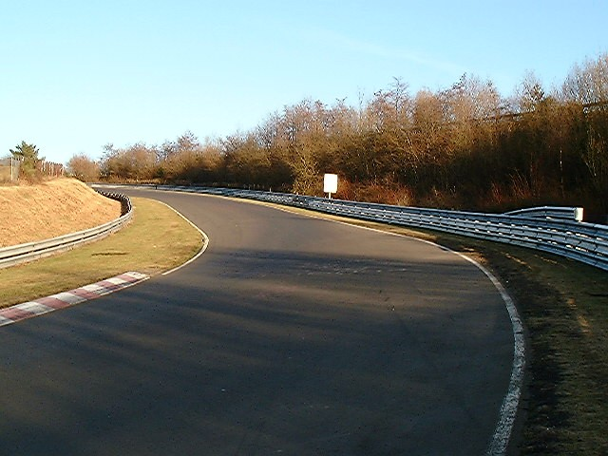

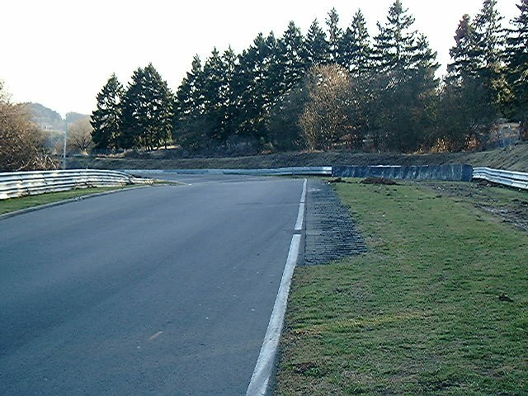

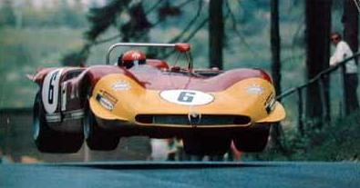

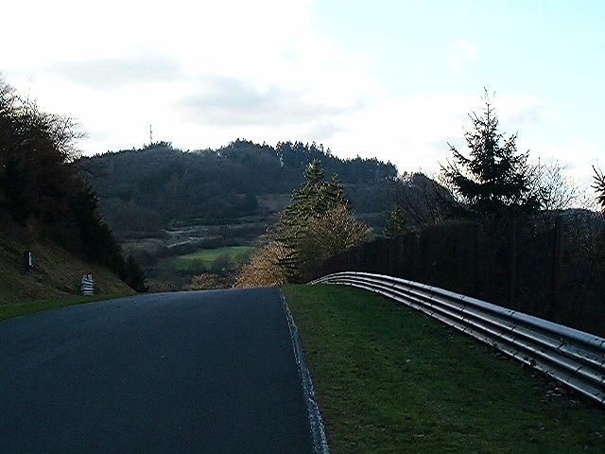

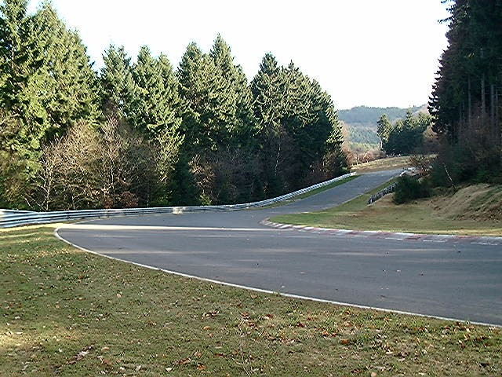

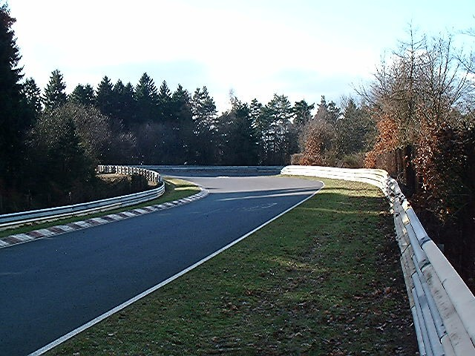

Many thanks to Jon Reeves for allowing me to pillage his photos of the Ring for the above quiz.

